Assignment 1

UML Diagram :

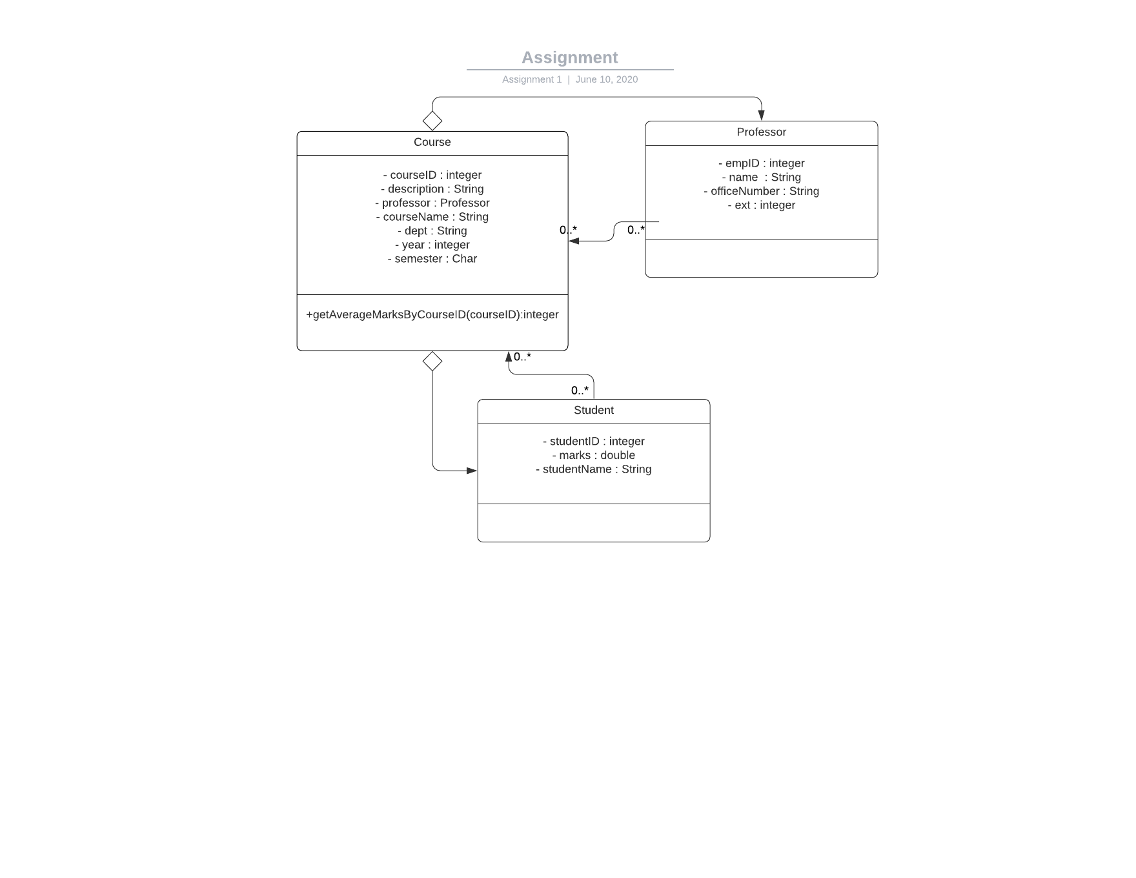

Java implementation and output :

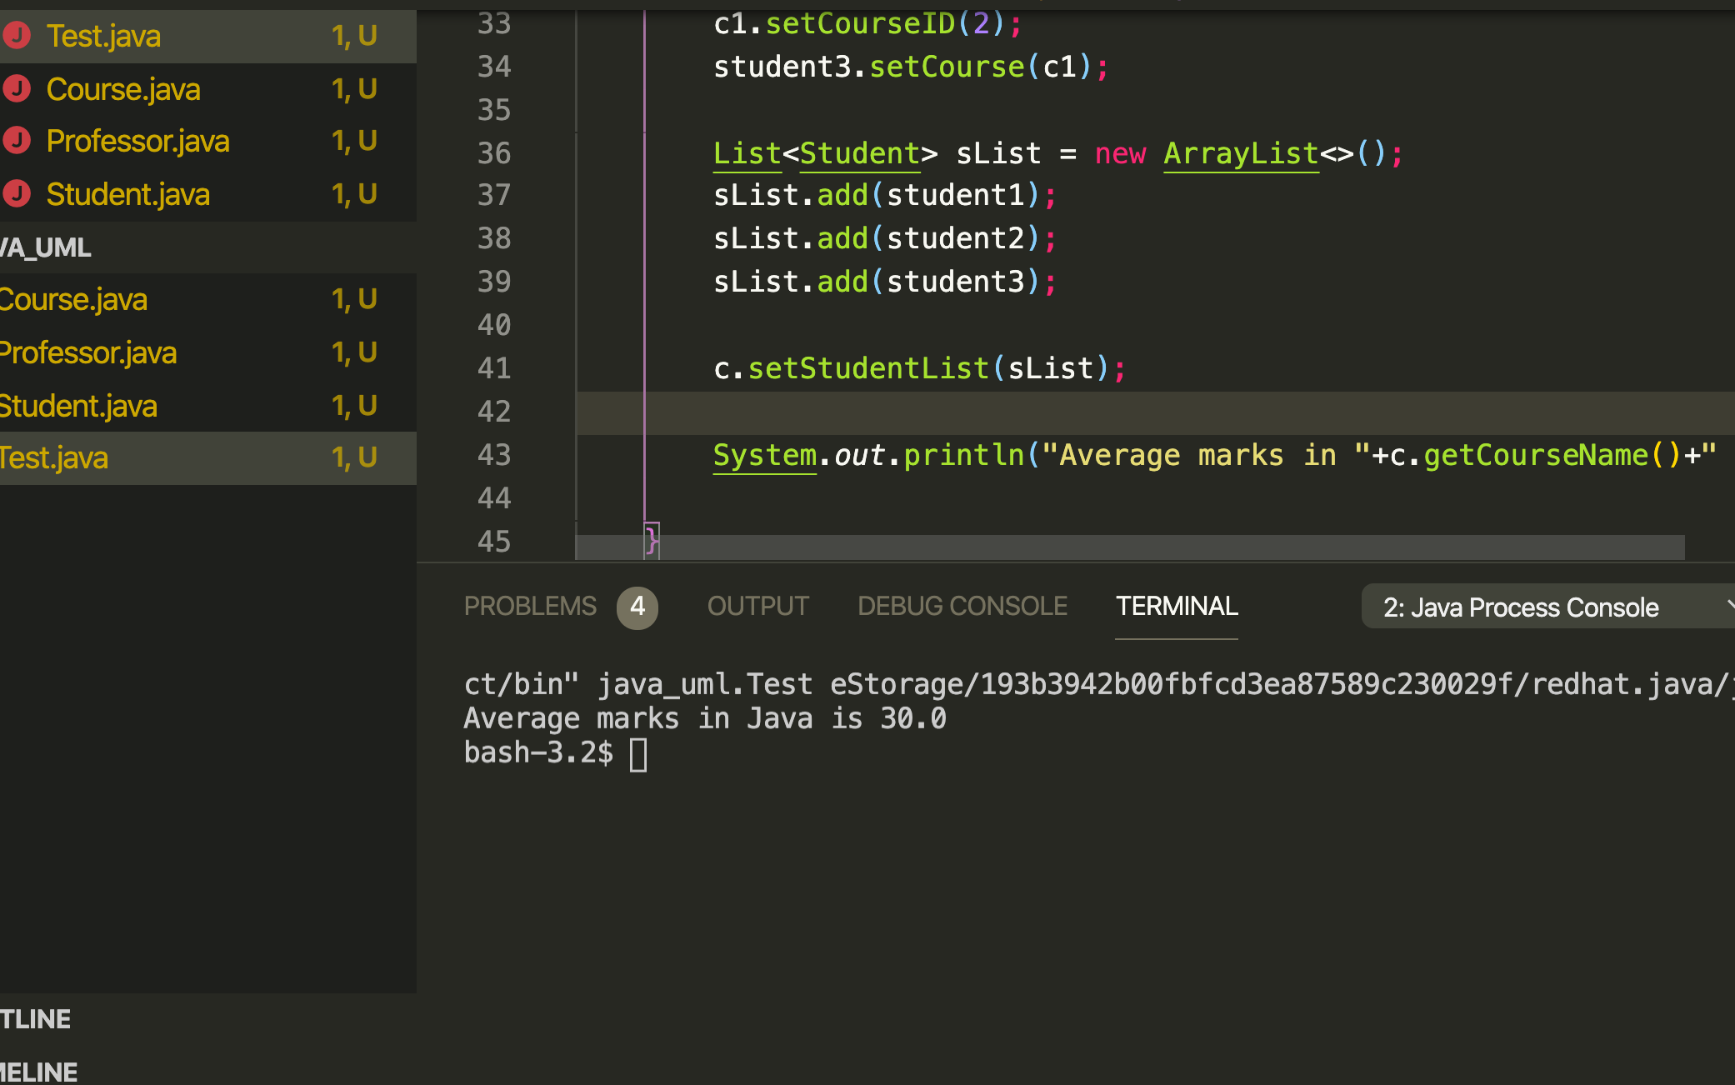

Reflations :

3.1

I have added 3 classes named Student , Course and Professor as per requirement stated and in UML diagram added aggregation as well as multiplicity for example course has too many student and professor

3.2 essential classes will be course, student and professor

Methods apart from getter and setter are getAverageMarksByCourseID in course class

Classes are initialized with parameterized constructor where needed and with setter value to add future reference for classes in particular professor as well as student

getAverageMarksByCourseID method will have courseid in parameter and will be counting average marks of student in the particular courseid

3.3



3.4

I have faced errors during getting list of students in course

For these errors i again recall my knowledge based on what i have learned in classes and some example on the internet

For solving problems i deeply look into some example on the internet which might have same use case of ours

For comments i used simple comments where i made logic

As stated in test.java class i inputted different data and calculated average marks based on course id in particular i added different course object for student 3 and checked average of other 2 and it worked perfectly

For code optimization i took a look on all the methods and variable created were in use or not and removed some if not in use

Made all variable private and generated proper getter and setter which i can use later

Removed unnecessary ifs and else as well as removed duplicate code for checking marks ‘’

I used a google search most to look for the aggregation and followed some links like

<https://medium.com/@smagid_allThings/uml-class-diagrams-tutorial-step-by-step-520fd83b300b>

<https://www.w3resource.com/java-exercises/basic/java-basic-exercise-245.php>

Thanks